Remove Unapplied Amounts and apply the cash in CASHENT as a new check - Example

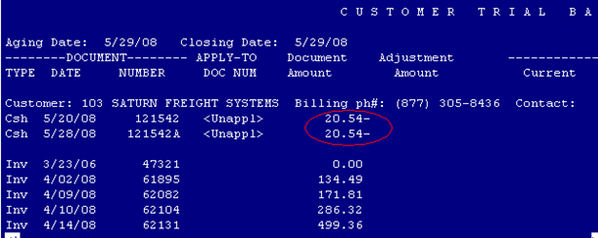

- Fast Path: CASHENT
- Create a new batch by pressing F11. Enter -20.54 as your amount.

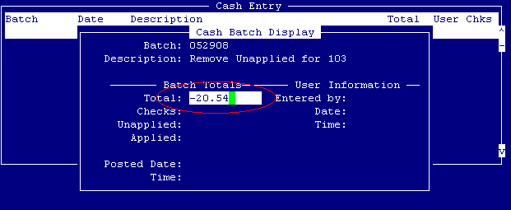

- Highlight the batch and press F12, then F11 to create a new entry.
  - Enter the check number such as 121542C
  - Enter the Customer number such as 103
  - Enter the Rcpt Date (can be original date of check or any date you select)
  - Enter the total amount -20.54 and save /close

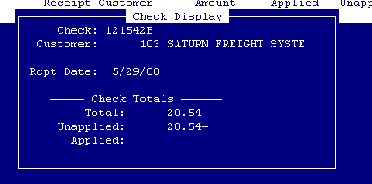

  - While highlighted on that same entry, press F12 then F4:
Create an unapplied transaction for 20.54-? Yes, Enter
    - Enter Customer Number such as 103
    - Enter Memo (you can enter any memo as needed – To Clear Unapplied Amount, etc.)

Your batch should now show an * and you can run CASHPO to post the batch.

- Fast Path: MOVECASH

Enter the customer number such as 103

Press Enter on just the matching negative / positive items to create a total of zero at the bottom of the page.

F2, Enter to save and close

Note: If you have extra items in MOVECASH, you can leave them in Unapplied and not select them. The items you select should always show a Total Unapplied of zero (bottom of the screen).

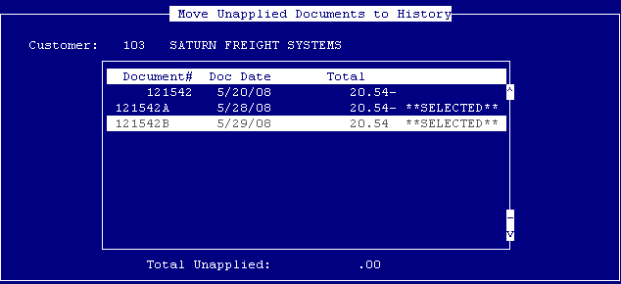

- Create a new cash batch in CASHENT using the same amount, but as a positive. Apply the cash as you would like any other check.

